**Lab 3. Breadboard and logic probe**

**I. Introduction**

1. **The solderless breadboards have many holes or sockets where you can insert the leads of components or wires needed to build a circuit.**

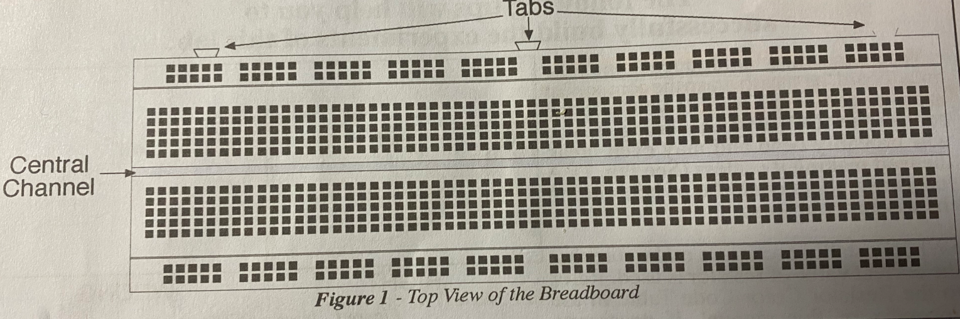

1. **Above and below the central channel, there are many columns of five socket. The five sockets in each column are electrically connected.**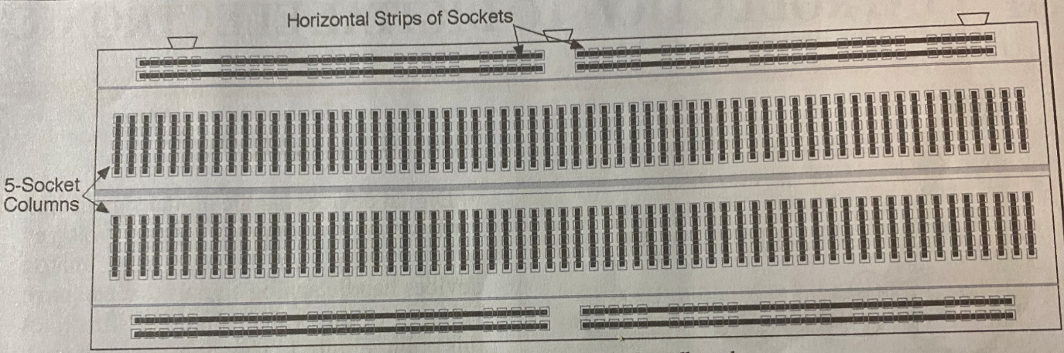

**Fig. 2 Internal connections of the breadboard**

**If we look at 1 five sockets column. It consists of a five-metal clip.** 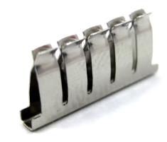

1. **Two horizontal sets of sockets at the top and two at the bottom, that are interconnected. All these horizontal sets of sockets are used as power buses: positive and negative bus strips.**

II. Notice

1. Push the lead or wire firmly into the sockets.
2. When inserting components into the breadboard, make sure to grasp the component near the end of the lead. If you hold the component itself when inserting it, you may bend and even break the lead. A long nose plier may help a lot.

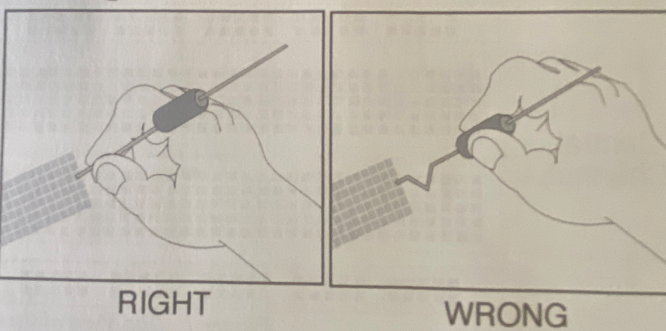

1. Some components have polarity. Some are not.
2. Do not put two wires or leads into same socket.

**III. Task one**

Parts: battery snap, 1N4001 diode, four jumper wires, three 3 ¾ long wires

1. **Use four jumper wires and two 3 ¾ long wires connect all the horizontal positive bus strips together, also connect all the horizontal negative bus strips together.**
2. **Insert two leads of the battery strip in the two leftmost column sockets. (red wire(+), black wire(-)). Connect the protective diode and switch wire as figure below indicates.**

**Protective diode: A protection diode used in any circuit that allows the flow of current in the forward direction, because the current will not flow in the reverse direction. It protects the components which are responsive to the flow of current through them in the wrong direction.**

**For 1N4001, a silver band denotes the cathode end of the diode**

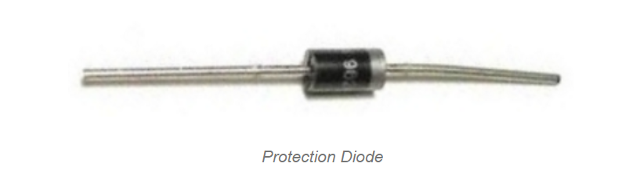

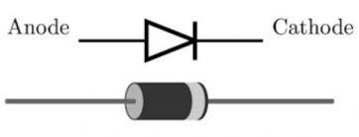

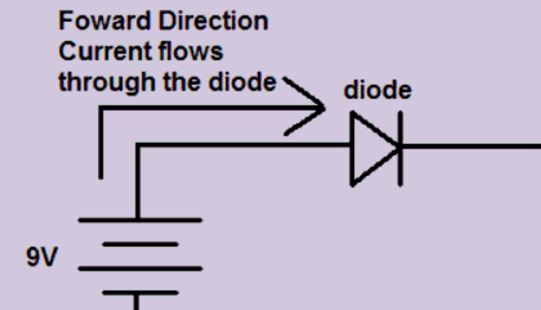

**When you use the switching wire for the later labs, before testing your work, always disconnect the end of the wire that goes to the battery snap. This can prevent the switch wire from accidentally being reconnected to the positive bus strip, which will destroy the protective diode.**

**IV. Task two-Build logic probe**

**1. Introduction**

1. **The logic probe is a device that indicates the logic state (High or Low) of a point in a digital circuit.**
2. **Each digital probe has three elements: a tip to touch the point of the circuit under test, indication of High and Low state, operating with power.**

**2. Task**

**2.1 Parts:**

1. pre-wired breadboard in task one
2. two 2.2K resistor (red, red, red)

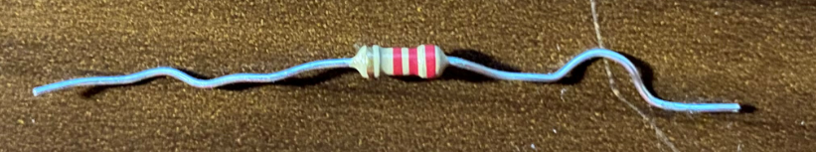

1. one red LED
2. one green LED
3. probe wire
4. one 9V battery
   1. **Notice:**
5. Based on task one, make additional connections.
6. The flat side of LED is cathode (Fig. 2). Current flows in only one direction (anode to cathode).
7. Never put the heads of same component in the same internal connected column or horizontal sockets (in Fig. 3).

Fig. 2. LED’s anode and cathode

Fig. 3. Internal connections of breadboard

* 1. **Requirement:**

1. Please use all the components listed in 2.1. The logic probe can probe the logical state (1/0) for any point in a digital circuit.
2. When not using the tip to probe, both red LED and green LED are both slightly turned ON.
3. When probing any point with the tip of the probe wire, red LED ON, green LED OFF indicates High voltage (1); green LED on, red LED OFF indicates Low voltage (0).

Fig. 4. Incomplete circuit diagram

Fig. 5 includes two High voltage and Low voltage conditions.

Fig. 5. High voltage and low voltage conditions

1. Please make the connections on your breadboard. **Do not connect the switch wire goes to the battery snap before all the connections are completed and well checked by me.**
2. Test your probe by probing point A, B, C, D, which is shown in Fig. 6 and demonstrate your results to me.

Fig. 6. Detected points listed

**When done, do not dismantle the built-in logic probe since we will use it for the later labs.**

**If you have finished all the tasks in class, no submission is needed in canvas. Otherwise, you need to take the picture for your connections and the pictures for each testing results of task 2.3.3. Put all the images together in a web file or PDF, upload them to the canvas portal I’m going to create.**